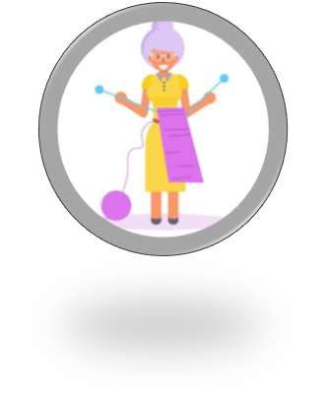The Grand(ma) Knit-a-Ton

Grannies Gloria White and Georgia Black have made a bet: whoever knits a scarf the fastest will be the greatest mother-knitter of all time.

The Knitting Gods think this will be pretty fun to watch, so they give the Grannies some Knitting Blessings (cards) to help them out.

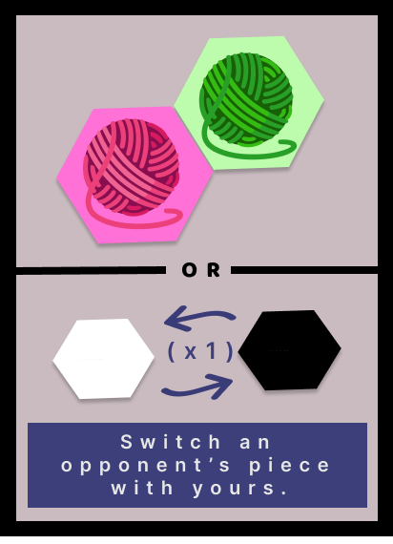**Pieces:**



* 60+ pieces for Granny White



* A picture containing text, businesscard

  Description automatically generated60+ pieces for Granny Black
* Shape

  Description automatically generated50+ blocking pieces
* 40 Knitting Blessings (cards)

**Gameplay:**

1. Each Granny starts with 4 Knitting Blessings (playable cards) in hand. The Granny must always have 4 Knitting Blessings in hand.
2. Both Grannies roll the dice: whoever gets the highest number starts first.
3. Each round, the Grannies take turns rolling the dice. If the Granny rolls:

> **Even Number**: Granny can play 2 Knitting Blessings this round;

> **Odd Number**: Granny can play 1 Knitting Blessing this round.

1. Shape

   Description automatically generatedKnitting Blessings allow the Grannies to choose between 1 of the 2 options represented: either picking the top side to place yarn pieces **OR** picking the bottom to activate an effect.

Player may place a piece on an empty blue yarn spot

Alternatively, player may use a block piece to block an empty spot

There are also some “broken” Knitting Blessings which allow for only one choice or, even worse, that don’t do anything, so beware!

1. A cat wearing a colorful garment

   Description automatically generated with low confidenceThe Displeased God/Switch Souls is a special and unique Knitting Blessing!

When drawn, it must be automatically played and its effect activates immediately.

Both Grannies switch sides, which means that Granny White plays as the Black side and vice-versa.

1. After a Knitting Blessing is played, place it on the discard pile and draw another one from the deck. If there are no Knitting Blessings left in the deck, re-shuffle the discard pile into the deck.
2. A Granny wins when she has a scarf connecting the top and bottom of the board!

**Knitting Blessings Cheat-Sheet:**

|  |  |  |  |
| --- | --- | --- | --- |
|  |  |  |  |
| Place 1 piece in a yarn spot of the color represented (blue, in this case) | Place 2 pieces in yarn spots of the colors represented (one pink and one green, in this case) | Place 3 pieces in yarn spots of the colors represented (one blue, one pink, and one green, in this case) | Replace 1 piece of the opposing Granny with your own  The piece must be in a yarn spot of the color represented (pink, in this case) |
|  |  |  |  |
| Block a yarn spot (for both Grannies) | Unblock a yarn spot (for both players) | Switch a number of your own pieces with your opposing Granny's pieces  (only 1 in this case) | Discard an opposing Granny’s card |

**Vassal Cheat-Sheet:**

|  |  |  |  |  |
| --- | --- | --- | --- | --- |
| **Re-shuffle** | **Flip Card Indefinitely** | **Send Played Cards to Discard Pile** | **Send Discard Pile to Deck and Re-shuffle** | **Switch Souls** |
| Automatic | Right-Click Card – Flip Card Around | Right Click Played Cards – Send to Discarded | Right Click Discard Pile – Send all cards to Regular Deck | Retire – Switch to observer then to opposing Granny |